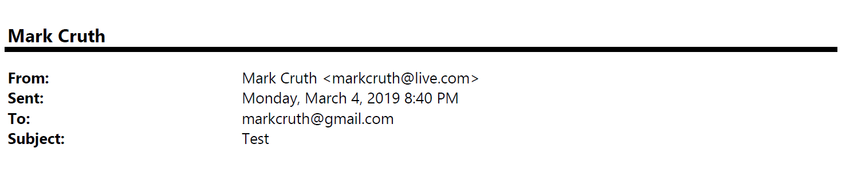
Organization Reimagination Team

Monday, February 11, 2025 8:32 AM
org-reimagination@reimaginecorp.com
Don’t Let Us Become Valve!

I’m excited for this move towards being a flat organization. I’ve raised the issue about bad decision making and poor empowerment for years…glad something is finally happening about it!

One thing I wanted to bring to your attention is an article I was reading over the weekend about Valve Software, one of the better know “flat” organizations out in the world. Here’s the link:

https://www.theguardian.com/commentisfree/2018/jul/30/no-bosses-managers-flat-hierachy-workplace-tech-hollywood

It sounds like more and more people are speaking up that within Valve there are two groups of people; the “in-crowd” and then everyone else…if you’re in the in-crowd (which is usually those the founders like) you’re safe and life is good. If you’re everyone else, you must watch out to ensure you don’t do something that gets you fired.

I wanted to bring this up because as you think about what our world looks like in the future, please make sure we don’t inadvertently create an “in-crowd.” I know our CEO and Board are all about this change, but when the going gets tough I don’t want to see them fall back on old ways…that would be devastating! How can we keep the right checks and balances in place so no one has to feel they have to suck up to someone to stay off the “we have to let you go” list…that’s not what this change we’re going through is about.

Thank you for listening! You’re all rock stars for helping us make this move!

Kimberly

