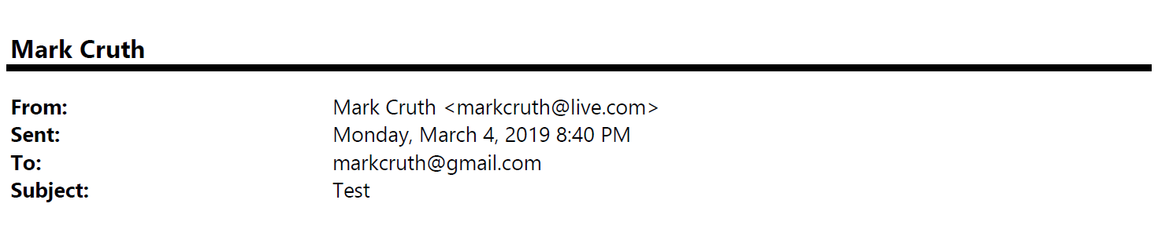
Organization Reimagination Team

Monday, March 4, 2025 8:40 PM
org-reimagination@reimaginecorp.com
All this work for nothing…

Good evening,

I know this isn’t any fault of yours, but I’m severally frustrated with this move to being “flat”…whatever that means. I’ve spent the last 10 years at this company building up my career. I went from being a simple sales associate to now the Sr. Manager for Training in North America. I have 40 people I support and feel real pride in what I’ve accomplished in the organization and the people I’ve helped grow. What I’m frustrated about is that with this move to being flat and eliminating all forms of management we’ve stripped away all the hard work and equity people like myself have built up in our career. I mean, what do you expect us to do now?

Again, I apologize for venting. I’m truly just worried that I’ve spent the last 10 year building up a career here, only to have it all taken away with a wave of the hand…it’s disheartening. I want the best for our team members but I know I’m not alone in this thinking …especially among my peers in leadership.

As you consider what this transformation looks like, please take these thoughts into consideration.

Thank you,

Rob Low
Sr. Manager, NA Training

