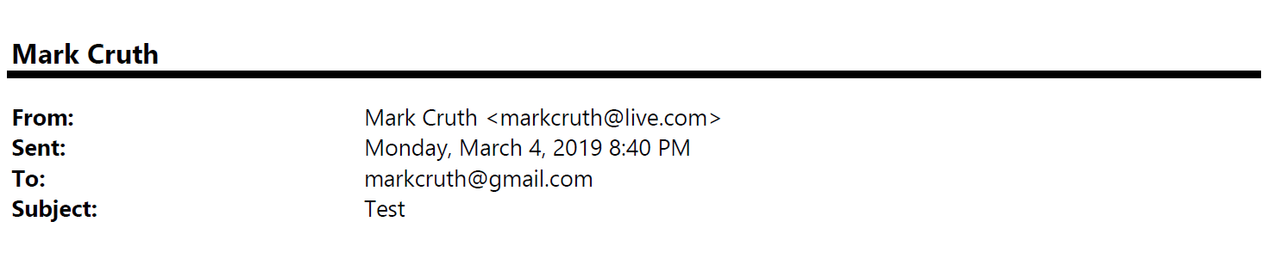
Organization Reimagination Team

Tuesday, February 5, 2025 10:59 AM
org-reimagination@reimaginecorp.com
Mergers and Acquisitions

Good morning,

I work in our mergers and acquisitions group and was curious what this new “flat” organization structure means for how we acquire new companies. One of the main reasons ReimagineCorp has grown so significantly over the last several years is due to our acquisition of several similar companies. In each acquisition our CEO played a pivotal role in the negotiation of the deal, as well as had final say in moving forward with each deal. If we’re distributing decision making authority who will end up making the call on future acquisitions? Note that we are currently pursuing two acquisitions at this time that will likely close at the end of the year.

Any help in understanding what this new paradigm means for mergers and acquisitions would be greatly appreciated.

Tom Ball

